Griffin Sykes, Michael Tadeo, Davis Yu
Stat 4210
Project #2
Introduction
The question we are taking under consideration is, “Do either the version of the game played or the presence of a distraction affect the time it takes a player to complete the game?” In this study, we are looking to see if either the game version, babies or animals, and the presence of a districation, ‘The Office’ clips, has an affect on our response variable, which is the time it takes to complete the game in seconds. We have two categorical explanatory variables within our study, which are the version of the game and the presence of a distraction. These are being compared to our quantitative response variable, which is the time taken to complete the game. Our scope of inquiry will be college students at the University of Georgia. Every data point in our set is a UGA student, so naturally this is the only population we can truly draw conclusions about.

Methods
Model: $y=α+β_{1}x_{1}+β_{2}^{}x_{2}+β_{12}^{}x_{12}+ϵ$
The true time to complete the game is $α$when all other explanatory variables are zero. The true change in the time to finish the game when the game is animal version is $β_{1}$, for any fixed value of the other explanatory variables. The true change in the time to finish the game when the game has a distraction is $β_{2}$, for any fixed value of the other explanatory variables. The interaction between the two variables is $β_{12}$, for any fixed value of the other explanatory variables. The random error is given by $ϵ$.
Since the explanatory variables version and distraction are independent of each other, we will be conducting the two-way ANOVA to predict the true change in time to complete the game. Then we will analyze the effect of each explanatory variable for evidence of the difference in the means of each variable. In terms of our hypotheses, our null hypothesis states that the changes in population means are the same in each category of one factor, when averaged over the levels of the other factor, which gives us 4 means. This would invoke no effect on the time it took for a player to complete the game. Our alternate hypothesis states that there is an effect on the time, when taking into consideration our two factors, which are our 2 explanatory variables.
$1. H_{0}=$The time taken to complete the game in seconds is the same for both the animal and babies versions of the game when averaged over both distraction and no distraction groups.
$H_{A}=$ The time taken to complete the game in seconds is different when analyzing the animal and babies versions of the game when averaged over both distraction and no distraction groups.
2. $H_{0}=$The time taken to complete the game in seconds is the same when looking at the distraction and no distraction groups when averaged over both versions of the game.
$H_{A}=$The time taken to complete the game in seconds is different when looking at the distraction and no distraction groups when averaged over both versions of the game.
3. $H_{0}=$The effect is the same when looking at the effect the version of the game has on the time a user takes to complete the game for both distraction and no distraction populations.
$H_{A}=$The effect is different when looking at the effect the version of the game has on the time a user takes to complete the game for both distraction and no distraction populations.
$x_{1}=1 if version is animals, 0 if versions is babies, or not animals;$ $x_{2 }= 1 if there is a distraction, 0 if there is no distraction$
While looking at the dataset, there seems to be a pretty big outlier, although we can’t be completely sure, because we have to assume that the data is accurate. If one wanted to improve the statistical significance of the study, ID #57 has a time of 2.05 seconds, which has a big time discrepancy, and it would get removed. Additionally, we may run follow-up tests, like Tukey’s method, based on the findings of the two-way ANOVA test to find an effect.
The assumptions that must be checked before continuing with a two-way ANOVA test are as follows. First, the data must be the result of random sampling or a randomized experiment. Since the data comes from a randomized experiment conducted on the population of the students in class, and each student is randomly assigned, this assumption is met. Second, the response variable must be quantitative and the predictors must be categorical. The response variable is the amount of time it takes for the student to complete the matching game, which is a quantitative variable. The two predictors are which memory game the student played, babies or animals, and whether or not they were distracted during the game. These are both categorical variables, so this assumption is met as well. Third, the population standard deviations must be the same or close to the same. There are four population standard deviations that need to be checked. The standard deviation for non-distracted individuals who played the animals memory game, or population 1, is 17.41 seconds. The standard deviation for non-distracted individuals who played the babies memory game, or population 2, is 21.36. The standard deviation for distracted individuals who played the animals memory game, or population 3, is 26.86. The standard deviation for distracted individuals who played the babies memory game, or population 4, is 19.53. Although these values are not the same, only being a few seconds off isn't too big of a deal so we’ll say this assumption is met as well. The final condition that must be met is that each of the population distributions must be normal or relatively normal.
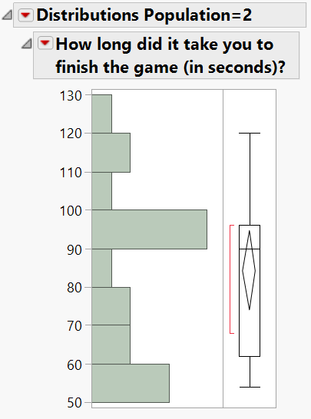
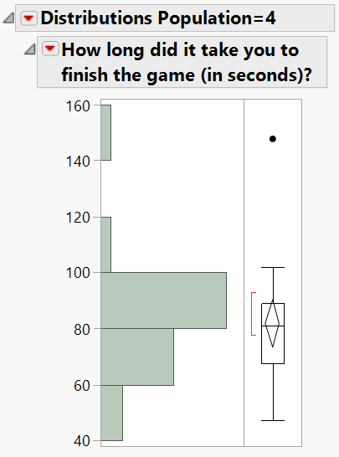
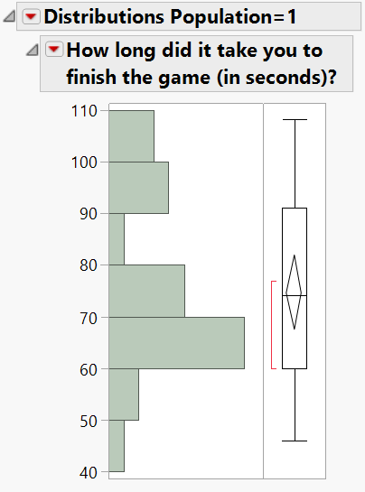
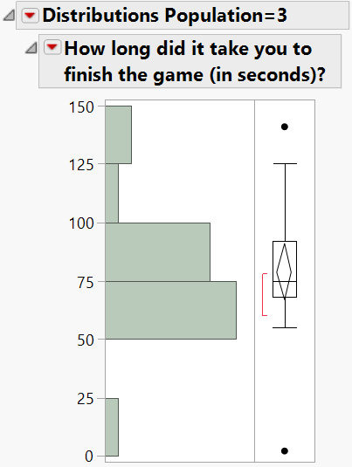
Figure 2.1

Figure 2.1 shown above is the sample distribution of each of the four populations mentioned above. Since the data is the result of a randomized experiment, we can assume that these sample distributions are representative of the population. In each of the distributions shown above, they follow a roughly unimodal and symmetrical pattern. As these sample distributions are representative of the total population, it is fair to assume that our population distribution will be normal, thus satisfying our final condition. Now that each of the conditions have been accounted for, we can continue with the two-way ANOVA test.

Analysis
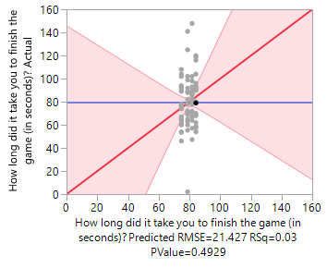
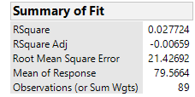
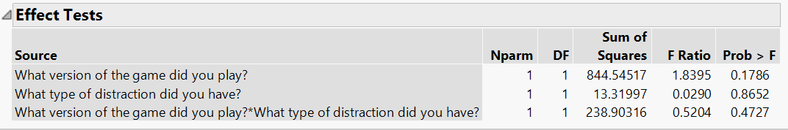
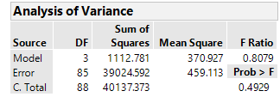
Figure 3.1
As seen in our ANOVA table, the F-ratio is 0.8079 which is relatively low while the p-value is 0.4929 which is relatively high. Such a large p-value shows that this is fairly weak evidence to say that the time it takes to complete the game is affected by which version of the game a person plays and if they were distracted or not while playing the game.

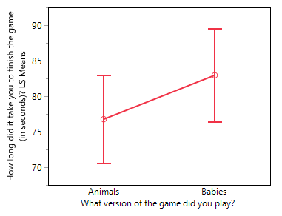
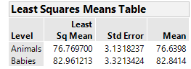
Which game was played:

Figure 3.2
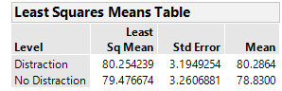
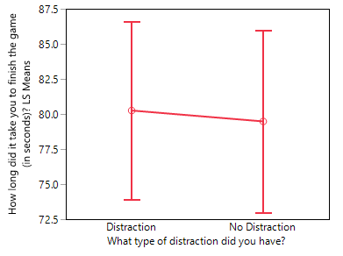
Was a Distraction Present:

Figure 3.3
When analyzing Figure 3.2, we can see a big difference depending on the version of the game played. The animals version of the game is completed ~6 seconds faster than it takes users who played the babies version on average. This effect doesn’t transfer as much over to the presence of a distraction in Figure 3.3, as seen from the ~1 second time faster for people with no distraction.

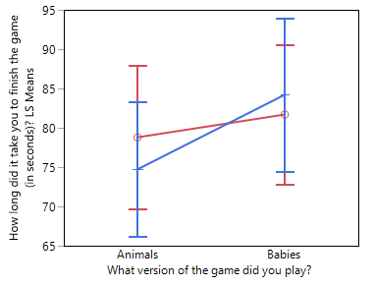
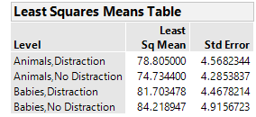
Both Predictors:
Figure 3.4
Figure 3.4 displays an interaction plot between the presence of a distraction taking into consideration whether the player used the animals or babies version. When analyzing the plot, one can see there is an effect between the game versions when no distraction is present on average, as the animal game has lower time of ~7.5 seconds on average than the baby version of the game. Additionally, one can see that there is a difference between each game version times when looking at whether the presence of a distraction, as there is an ~4 second difference for the animal version and ~2.5 second difference for the baby version under the condition of a distraction.

Conclusions
From this analysis, specifically Figure 3.1 Effect Tests Table, we can see that since the p-value for the versions of the game is 0.1786 which is relatively low and the F-ratio is 1.8359 relatively high. These test statistics are moderately strong evidence for us to conclude that the null hypothesis on the versions of the game is rejected if we increase the alpha level to 0.20. Meanwhile, the p-value for the distraction is 0.8652 which is high and the F-ratio is 0.0290 which is really small. These indicates that there is very weak evidence for us to reject the null hypothesis on the distraction of the game. However, the p-value for the different effect is 0.4727 which is somewhat high and the F-ratio is 0. 5204 which is relatively low. We say that there is some but not strong enough evidence to reject the null hypothesis on the different effects. Even though we have been able to reject the first part of the null hypothesis with relatively strong evidence, the test statistics do not signify a clear and strong evidence to reach more conclusive results. Thus, we may need additional tests and investigations to improve the interpretation of these results. Because all the sample statistics have fairly similar measurements and small differences between the means, the two-way ANOVA may not be able to find clear results from the readings of the statistics to start with.
In general, none of the individual or grouped explanatory variables appear to have a clear effect on the test results. Especially, when our f-ratio is only 0.8079 which is a sign that indicates too much error. Thus, it is hard to conclude that any of the predictors have an effect on the variability of the sample. However, it does appear that the version of the test seems to have a much greater effect than the presence of distraction during the game.
There are some clear limitations that can be drawn from this study that may affect what can actually be concluded from this study. First, as seen from the Summary of Fit table in Figure 3.1, the R² value of 0.027 is extremely low, meaning that the model only explains 2.7% of the variability. Since our model explains so little of the variability, perhaps the two variables of which game was played and whether or not a distraction is present are not enough to explain a substantial amount of the variability. Another limitation is the aforementioned ID #57 and their time it took them to complete the game. Although we must assume the data is correct, a time of 2.05 seconds appears to be an impossible length of time to complete the game. This massive outlier can have a huge affect on the results of the study. The final limitation to discuss would simply be small sample size. There are only 89 entries in our data, which is not a large sample size for a study that has two different explanatory variables.
Moving forward one should attempt to adjust for these limitations. Another sample can be assembled, but maybe instead of just 89 students, it can be comprised of many more.This could be done by sampling more classes than just sections of STAT 4210. To prevent another incident like ID #57 from occurring, perhaps have the students record their times on the board. If a value that raises concern is written, one would be able to simply ask the student to ensure that the time they wrote is indeed the correct time. Also, we may try to conduct another test specifically designed to investigate the effect of the version of the game on the test. After accounting for these limitations, perhaps another study would be able to more accurately make inferences about the population.
Additionally, we could run a follow-up Tukey’s method to consider and find statistically significant differences between all of the possible paired means. It is used to reduce the type-one error of the overall value because it gives us narrower confidence intervals. Furthermore, we could compare times adding in another explanatory variable, such as gender, and analyze which gender has a faster time under many different conditions using Tukey’s method.

